Architecture

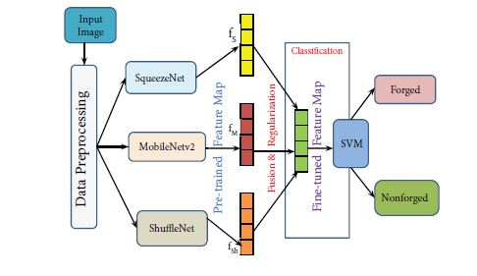

Class Diagram



User Case Diagram



Sequence Diagram



Collaboration Diagram

